Logical Reasoning in Programming

Logical reasoning is a fundamental skill in programming that involves using systematic thinking to solve problems, make decisions, and understand the flow of programs. It requires a clear understanding of concepts, the ability to identify patterns, and the skill to apply logical principles to develop efficient and correct solutions.

### **Key Concepts in Logical Reasoning for Programming**

1. **Conditional Statements**: Conditional statements, such as if, else, and switch, are used to execute specific blocks of code based on certain conditions. These statements allow the programmer to make decisions in the code flow. Logical operators like && (AND), || (OR), and ! (NOT) are often used in conjunction with conditional statements to create more complex conditions.
2. **Loops**: Loops are structures that execute a block of code repeatedly. for, while, and do-while are common loop constructs in most programming languages. Logical reasoning helps in determining the condition under which loops should run, ensuring that loops do not run indefinitely or with incorrect initialization and termination conditions.
3. **Boolean Logic**: Boolean logic is essential for logical reasoning in programming. It involves using values true and false to perform operations. Understanding how to combine conditions using AND, OR, and NOT helps in creating complex logical expressions. For instance, (a > 0 && b < 10) checks if a is greater than 0 and b is less than 10.
4. **Nested Loops and Conditions**: In many cases, problems require nested loops or nested conditional statements. Logical reasoning is crucial for determining the appropriate nesting level and the conditions required for each loop or branch. This can help avoid common pitfalls like infinite loops or incorrect logic.
5. **Logical Gates**: For those familiar with digital logic, understanding logical gates (AND, OR, NOT, XOR, etc.) is beneficial. This knowledge helps in understanding how different logical operations are implemented in hardware and can be used to design efficient algorithms.

### **Techniques in Logical Reasoning**

1. **Step-by-Step Problem Solving**: Break down the problem into smaller, manageable steps. Identify the input, process, and output, and then define the logical steps needed to achieve the desired result. This helps in designing algorithms that are easy to understand and debug.
2. **Flowcharts and Pseudocode**: Creating flowcharts and writing pseudocode are effective ways to visualize the logic before implementing it in code. These tools help in identifying any logical flaws in the proposed solution and ensure that the logic flows smoothly.
3. **Dry Run**: A dry run involves manually executing the logic of a program with a set of sample inputs to observe how the code behaves. It helps in verifying the correctness of logical reasoning by showing what happens at each step of the execution.
4. **Testing**: Logical reasoning in programming requires thorough testing to ensure that the solution works as expected for all possible inputs. Writing test cases that cover edge cases and boundary conditions can help in identifying logical errors.
5. **Refactoring**: After identifying logical errors or inefficiencies, refactoring the code is essential. This involves revising the code to improve its logical flow, making it more concise, readable, and efficient.

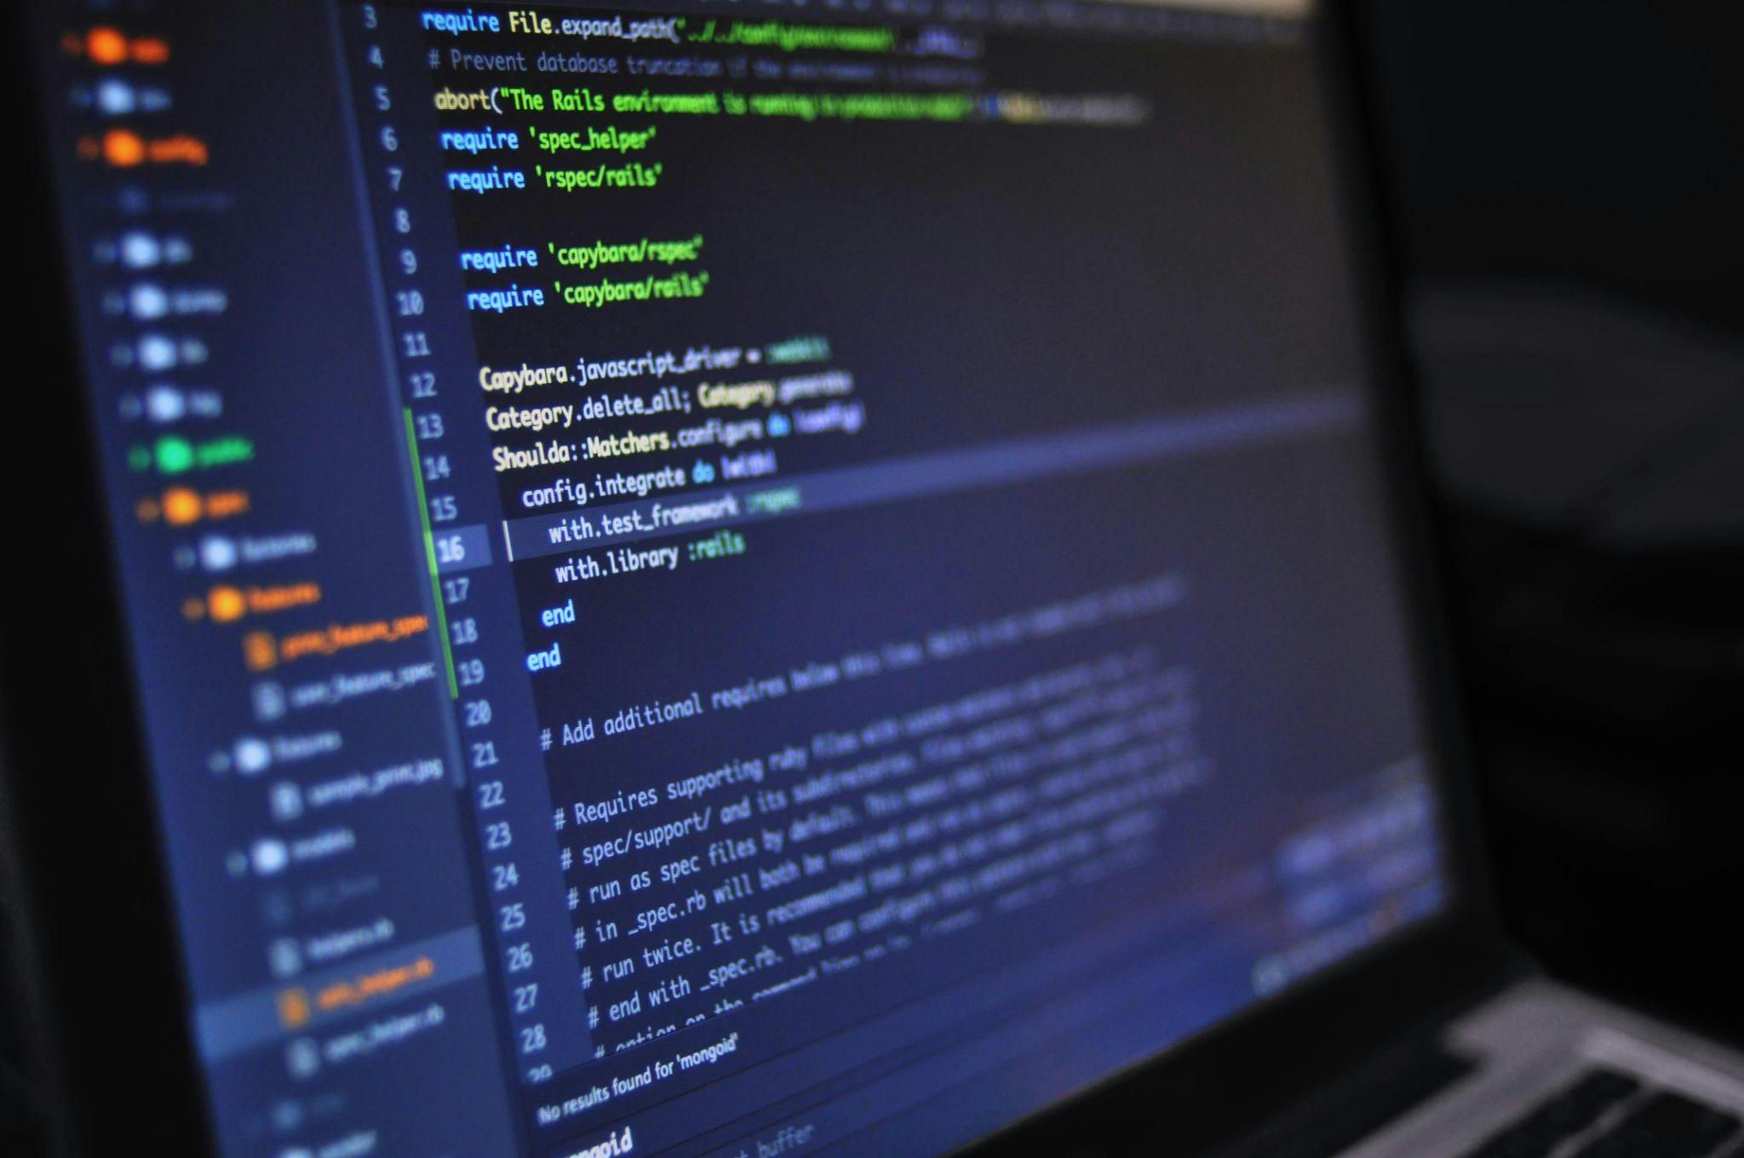

### **Common Pitfalls in Logical Reasoning**

1. **Misuse of Logical Operators**: Incorrect use of logical operators can lead to unexpected behavior in the program. For example, using & instead of && in C/C++ can lead to unintended results due to the difference in short-circuit evaluation.
2. **Overlooking Initial Conditions**: Failing to set appropriate initial conditions for loops and conditional statements can cause infinite loops or the code not to execute as intended.
3. **Confusing the Assignment (=) and Equality (==) Operators**: This common mistake can lead to logical errors where the program assigns a value instead of comparing it.
4. **Neglecting the Else Clause**: In conditional statements, forgetting to provide an else clause when required can result in unexpected behavior if none of the conditions are met.
5. **Lack of Consideration for All Possible Scenarios**: Logical reasoning should take into account all possible scenarios, including edge cases. Not doing so can lead to incorrect assumptions and faulty programs.

### **Conclusion**

Logical reasoning is a crucial aspect of programming that enables developers to create robust, efficient, and error-free code. By mastering logical concepts and techniques, programmers can develop algorithms and solutions that are not only correct but also optimal in terms of performance. It requires practice, attention to detail, and a systematic approach to problem-solving to excel in logical reasoning in programming.